

DAMBI DOLLO UNIVERSITY
COLLEGE OF ENGINEERING AND TECHNOLOGY
DEPARTMENT OF INFORMATION TECHNOLOGY
FINAL PROJECT II
Online Student Attendance Management System for DADU

Submitted as Partial fulfillment of the requirements for the INDUSTRIAL PROJECT-2 Report for the Degree of Bachelor of Science in Information Technology Under the Supervision of Mr. Geleta Tilahun (Msc) Department of Information Technology

Jan, 1 2026 GC
Dambi Dollo, Ethiopia
College: College of Engineering and Technology
Program: Information Technology
Project: Web-Based Attendance Management System for Dambi Dollo University
I certify that this project satisfies all the requirements as a project for the degree of Bachelor of Science.
Name of program coordinator Signature
Group members
Name Signature
1.
2.
3.
4.
5.
6.
This is to certify that I have read this project and that in my opinion it is fully adequate, in scope and quality, as a thesis for the degree of Bachelor of Science.
Name of Advisor______________________________ Signature____________
Examining committee members Signature Date
Examiner 1
Examiner 2
It is approved that this project has been written in compliance with the formatting rules laid down by the school of the university.

Acknowledgement
First and foremost, we would like to thank our almighty God, who gives us, patience, wisdom, love, healthy, and ability to walk through all the difficulties and obstacles during the period of our study. We will not have achieved anything in our life if not by his grace. Our deepest gratitude goes to our advisor Mr. Geleta Tilahun who have spent his valuable time and guidance, valuable suggestion, moral support, and constant encouragement in advising us on this project. Their advices and guidance have been instrumental for the timely completion of the project. And also, we would like to thank for staff members of Information systems department who have contributed absolutely to the success of this documentation. We would also like Dambi Dollo University,
College of Engineering and Technology, Information Technology Department and guidance they have bestowed upon us. The knowledge we have acquired from this will guide us towards achieving our goal for this we are truly grateful. Finally, I would like to thank our family and friends for their encouragement and support throughout the years.

Contents

Acknowledgement iii
CHAPTER ONE 1
- INTRODUCTION 1
  - Background of the Study 1
  - Problem and Motivation 2
  - Objectives of study 3
    - General objective 3
    - Specific Objective 3
  - Methodology and Tools 3
    - Data Collection 4
    - Systems Analysis and Design 4
    - System Development Tools 5
  - Scope and Limitations 7
  - Significance of the Study 7
  - Feasibility Study: 7
    - Economically Feasibility: 8
    - Technical feasibility: 8
    - Operational Feasibility: 8
  - Work and Budget Plan 9
    - Work Schedule 9
    - Budget Plan 9
  - Document organization 10
ii
Chapter Two 11
- System Analysis 11
  - Introduction 11
  - Description of Existing System 11
  - Literature Review 12
  - Players of Existing System 13
    - Lecturer 13
    - Department 14
    - Student 14
  - Bottlenecks of Existing system 14
  - Business Rules of Existing System 15
CHAPTER THREE 17
- SYSTEM ANALYSIS 17
  - Overview of Proposed System 17
    - Features of the New System 18
  - Proposed architecture for the Attendance Management System 19
  - Requirement Analysis 19
    - Functional Requirements 20
    - Non-Functional Requirements 22
  - Usecase Identification 24
  - Usecase Diagram 25
  - Use Case Description 27
  - Sequence Diagram 36
  - Activity Diagram 42
iii
Chapter Four 45
- System Design 45
  - Introduction 45
  - Design Goal 46
  - Class Diagram 47
  - Component Diagram 48
  - Deployment Diagram 49
References 50

List of Figures
Figure 3-1 Usecase Diagram 25
Figure 3-2 Sequence Diagram 33
Figure 3-3 Sequence Diagram for Create Account 34
Figure 3-4 Sequence Diagram for create standard 35
Figure 3-5 Sequence Diagram for Student Registration 36
Figure 3-6 Sequence Diagram for Prepare Attendance 37
Figure 3-7 Admin side Activity Diagram for Student Attendance Management System 38
Figure 3-8 Student side Activity Diagram for Student Attendance Management System 39
Figure 3-9 Staff side Activity Diagram for Student Attendance Management System 40
Figure 4-1 Class diagram 43
Figure 4-2 Component diagram 44
Figure 4-3 Deployment Diagram 45

v

List of Tables
Table 3-1 Non Functional Requirement 21
Table 3-2 Usecase Identification 23
Table 3-3 Login Usecase Description 26
Table 3-4 Manage User Usecase Description 27
Table 3-5 Usecase Description for Add Standard 28
Table 3-6 Usecase description for Prepare Attendance 29
Table 3-7 Usecase Description for Make Complain 31

vi

CHAPTER ONE

INTRODUCTION

Background of the Study
In our life today, the computer is one of many inventions that greatly affect our way of living. In fact, it is noted as an essential tool in many areas including business, government, industry, sciences, education, school, home, and in almost any company and establishment that existed. It can perform process data rapidly, accurately and reliable and by using these machines, spending a lot of time and effort in doing a certain task is minimized [1].
Computer nowadays has become the most needs of data and information processing. Computers have been very effective in many fields of work and study. It certainly helps man to make his task much easier and with great precision. In schools and universities, computers are used to maintain the basic flow of data and information and checking the credit status of the students. The computer is very useful in performing a great task in data and information processing, securing files, data, and information of the schools and people belong to it. Computer programmers now a day try to build and develop high-quality systems that are very useful. A computerized management system maintains the standard flow of data and information with highly secured and make data processing faster and easier. These computerized systems help one person, company, organization or any type of management agency throughout the world to enhance and develop its general profile.
Student attendance is a baseline factor in determining student success. (Great Schools Staff, 2016) The attendance is important because students are more likely to succeed in academics when they attend school consistently. It’s difficult for the teacher and the class to build their expertise and growth if a large number of students are often absent. In addition to falling behind in academics, students who are not in school on a regular basis are more likely to get into difficulty with the law and cause problems in their communities.
The world itself has become a global village of technology today, especially with the computer technology. With the advent of new technology, the world is now witnessing an easy way to keep information / data. Hence the introduction of computer is one of the greatest challenges

facing man today. Attendance Management System is software developed for daily student attendance in schools, colleges and institutes. It facilitates to access the attendance information of a particular student in a particular class. The information is sorted by the operators, which will be provided by the lecturer for a particular class. This system will also help in evaluating attendance eligibility criteria of a student. Since ages, attendance system has remained one of the most important systems for evaluating the working time of students in any college or school. In short, this project is used to mark the number of days present/absent in any academic year of students in a college, school etc. The software system also helps in evaluating the examination eligibility criteria for a student in the sense that only those students with attendance above 80% are allowed to sit for the semester exams. And this system will also help in evaluating attendance eligibility criteria of a student. In schools, attendance is important and mandatory [2]. Nowadays, due to the large number of students, it is efficient to use attendance management system to manage attendance in schools.

Problem and Motivation
In most educational institutions the attendance is taken manually. It is not only time consuming, but it is also unsecure and unreliable and it can be lost. Some instructors of Dambi Dollo University prepare attendance sheet before starting the class and take print of what they prepared for one semester. However, some staffs simply prepare attendance sheet for each class through writing some important header information. Whatever, currently all staffs of MTU using manually for attendance while this will be difficult for teachers to keep track of the large number of students, a student can help the other students or his/her friend through signing even the other student may be absent or come late in class, so it is not reliable.
To overcome these problems, I will develop a better system which is Web based; it is fully responsive where a user can use in mobile, tablets and different computer systems. In this system records are kept safe and secure and the attendance information of particular or all students of particular class can be accessed easily and without time consuming, the report is generated
automatically.

Objectives of study

General objective
To develop web-based attendance management system for taking attendance in classes and also manage student information along with their classes and subjects.

Specific Objective
To Review different literatures to understand the concept of our work and the software tools we preferred to use in our project.
- To understand the work flow existing system which will give roadmap for our system and to clearly state the problem of existing system.
- To collect the necessary information from the organization which elaborate how student attendance were managed.
- To analyze the functional requirement of student attendance management system and non- functional requirements.
- To handle panel Discussion forum
- To sketch out the logical and physical design based on the collected data
- To design user interface based on the physical design
- To implement backend on the developed front-end system.
- To generate the reports automatically whenever required.
- Appling different types of testing to check the accuracy of the attendance management system and also acceptance of the system by the organization
- To deploy attendance management system to the organization.

Methodology and Tools
Methodology is the way of identifying the roadmap that helps the designer and developer to identify the appropriate method and project design. This project will be carried out by simulating a manual system with automates system. collecting all necessary information collected by interviewing some staffs [3].

Data Collection
We used interview and observation to collect data that are necessary to develop the designed system.

Direct Observation
we observed the current system and we identified the problems in managing the student attendance information management systems. So, it helped us easy way to understand the system and to develop the project. By observing their system structure, we designed this project to solve their problems.

Interview technique
During interview we got the necessary information from the employees. We communicated with teachers, student and concerning bodies through asking different questions

Systems Analysis and Design
SAD is the process of breakdown an entire system into module, analyzing each module separately, and determining the relationship between system development process we used system modeling i.e., creating model of the system. System modeling is the process of creating a model of system by analyzing and organizing the system elements. This is the phase where deeply understanding of the existing system problems and finding alternative solution.
To design the system, we choose the concept of Object-oriented system analysis and design (OOSAD); Object-oriented modeling techniques and Unified modeling language (UML) tools. object oriented modeling technique is advantageous for the following reasons why we use it [4]:
- It enables us to comprehensively model a system before we develop it.
- Modification of the object implementation is easy because objects are loosely coupled.
- Understanding of the structure is easy because object-oriented modeling and tools used to represent real world entities.
- Direct manipulation of architectural components is possible because several object- oriented programming languages exist.
- UML is also the main tool we used for necessary software design and analysis.
- To develop diagrams and provide users with ready-to-use expressive modelling examples.
- It can be used for modelling a system independent of a platform language
- To design the blue print artifact of the system
- To present proposed designs and communicate with stakeholders.
- To understand requirements.

System Development Tools
For project development different tools are required these tools are both hard ware and software tools.
Our project used the following hardware tools.
- Computer: - used to develop the system.
- Pen: - used to write the drafting of the idea on the paper.
- A4 Sized Paper: - used to organize the idea before writing to the computer.
- This is used to draft all the ideas on the paper and to collect different information from any sources.
- Flash Disk: - used to store and secure and transfer data. Simplifies the complex application
Activities | Tools
Client-side coding | HTML, CSS, JavaScript
Platform | MS Windows
Database server | MYSQL
Webserver | Apache
Server-side scripting | PHP
Browsers | Any compatible Browsers IE 5.5/6.0/7.0, Mozilla Firefox3.0, Google chrome
Editors | VS code
Documentation | MS Word, MS Excel
 | MS PowerPoint
In addition to the above requirements, the project development requirements of our system are summarized as follow: -

Backend technology
- Server: Apache HTTP Server is used run the web server within Windows OS.
- Database: MySQL is common database in creating dynamic websites it is a high-speed database.
- Scripting Language: PHP (Hypertext preprocessor) is a server-side scripting language that can be used to access data from the database. Generally, Apache, MySQL, and PHP are open- source components that can be installed individually, they are usually installed together.

Front end technology
The Front end of this project used HTML, CSS and JavaScript: -
- HTML: used for user interface design. Mean that, every client must send to and receive the response from the server through using graphical user-interface. Generally, it is a tool to make communication between client user and server.
- CSS: designing user-interface is good. However, making the designed user-interface attractive and responsive is the main expected or main features in web programming language. Cascading style sheet the one which we will use to layout the user-interface.
- JavaScript: JavaScript programming language is the most powerful programming language used for validating user front end activities, calculation and etc. Restricting the input which users enter is very important aspect in programming language. For example, in real word the name any person must be written in alpha. Your web-based user-interface must keep this in the design. What if, the user enters alpha-numeric for name input field? In short, the most popular frame work in CSS and JavaScript are Bootstrap, jQuery and we will use them in our system to make it better interface and performance. Thanks to the advancement of the technology called NodeJS runtime environment, now adays JavaScript is used as full-stack technology.

Scope and Limitations
We planned to design and develop attendance management system for Dambi Dollo University for all departments. The design and platform of the project is a web-based system that manages the user and client registration and provides the functionality of recording the individual records of the students and teachers. The system also provides a search capability and generates reports of the attendance.

Significance of the Study
Each department Head or concerning body can easily monitor both student’s and teacher’s daily attendance for any kind of decision taken by teachers. The students can easily enter and record their daily attendance in a timely manner and have the record when they needed. Moreover, teachers can easily follow the students who attend the class and not attend the class. The major headache in manually attendance system is calculating the total number of attendances in which the student attended the class in order to permit the student to sit for final examination [2]. If the student attended more than 80%, he/she will only sit for the examination unless the final grade of the student become incomplete. The main advantages in which the organization will gain from this system are:
- To allow teachers to monitor students who are not actively attending the school.
- To secure the attendance record of the students and teachers.
- To automate summary and remarks for attendance, the participation of every student.
- To Eliminate duplicate data entry and errors in time and attendance entries.
- To Eliminate paperwork and save time.
Producing the right and full product for the first time is impossible because there are different constraints that restrict different developers to design and develop the full and complete system. That is why, at the end we recommend for the other researchers or developers who are interested to do their project in this area. Therefore, the other researcher will use this study as bench mark for their study.

Feasibility Study:
Feasibility analysis begins once the goals are defined. It starts by generating broad possible solutions, which are possible to give an indication of what the new system should look like. This is where creativity and imagination are used. Analysts must think up new ways of doing things- generate new ideas. There is no need to go into the detailed system operation yet. The solution should provide enough information to make reasonable estimates about project cost and give users an indication of how the new system will fit into the organization. It is important not to exert considerable effort at this stage only to find out that the project is not worthwhile or that there is a need significantly change the original goal. Feasibility of a new system means ensuring that the new system, which we are going to implement, is efficient and affordable. There are various types of feasibility to be determined. They are,

Economically Feasibility:
Development of this application is highly economically feasible. The only thing to be done is making an environment with an effective supervision. It is cost effective in the sense that has eliminated the paper work completely. The system is also time effective because the calculations are automated which are made at the end of the semester class or as per the user requirement.

Technical feasibility:
The technical requirement for the system is economic and it does not use any other additional Hardware and software. Technical evaluation must also assess whether the existing systems can be upgraded to use the new technology and whether the organization has the expertise to use it. Install all upgrades framework to make the layout of the system more attractive. This web-based application depends on different web browsers in order to interact with the user and intranet service, database as well as they easily generate attendance report to excel sheet.

Operational Feasibility:
The system working is quite easy to use and learn due to its simplicity and attractive interface. Novices’ user requires only short time training and demonstration for operating the system.
Technical performance includes issues such as determining whether the system can provide the right information for the department personnel student details, and whether the system can be organized so that it always delivers this information at the right place and on time using intranet services. Acceptance revolves around the current system and its personnel.

Document organization
This section deals with the structure of the document. Focus on listing the number of chapters and elaborate each chapter aim as much as possible. The document consists of six chapters including this chapter. Chapter two gives an overview on existing attendance system. The background information of existing system, some literature review along with related works to this project are reviewed in these chapter. Chapter three deals with system analysis regarding functional and non-functional requirement analysis along with studying proposed system architecture. Chapter four discusses about system design. This chapter draws out the business model and specification of the problem domain. The implementation is discussed in chapter five. The last chapter is all about conclusions and recommendations.

CHAPTER TWO

SYSTEM ANALYSIS

Introduction
Analysis can be defined as breaking up of any whole so as to find out their nature, function etc. It defines design as to make preliminary sketches of; to sketch a pattern or outline for plan. To plan and carry out especially by artistic arrangement or in a skillful wall. System analysis and design can be characterized as a set of techniques and processes, a community of interests, a culture and an intellectual orientation. This system manages to the analysis of the report creation and develops manual entry of the student attendance. First design the student’s entry form, staff allocation and time table allocation forms. This project will help the attendance system for the department calculate percentage and reports for eligibility criteria of examination. The application attendance entry system will provide flexible report for all students.

Description of Existing System
The Existing system is a manual entry for the students and the attendance was carried out in the hand written registers. In most educational institutions the attendance is taken manually. It is not only time consuming, but it is also unsecure and unreliable and it can be lost.
The whole session attendance is stored in register and at the end of the session the reports are generated. We are not interested in generating report in the middle of the session or as per the requirement because it takes more time in calculation. So, we are not able to get employees regularity report and take necessary action on employees whenever we want because of having very time-consuming process. Because, it is a tedious job to maintain the record for the user. The human effort is more here. The retrieval of the information is not as easy as the records are maintained in the hand written registers. This application requires correct feed on input into the respective field. Suppose the wrong inputs are entered, the application resist to work. Therefore, the user finds it difficult to use.
Some institutions are using punch card for attendance while this will be difficult for teachers to keep track of the large number of students because by using punch card, a student can help the other students or his/her friend to punch their card even the other student may be absent or come late in class, so it is not reliable. To overcome these problems, I have developed a better system which is Web based; it is fully responsive where a user can use in mobile, tablets and different computer systems. In this system records are kept safe and secure and the attendance information of particular or all students of particular class can be accessed easily and without time consuming, the report is generated automatically.

Literature Review
Online Attendance Management System is an application developed for student’s daily attendance in school. It helps to maintain the accurate record and generate summarized student attendance reports for the students by applying various criteria.
In a study conducted by Baltazar & Ragojos (1992) on a Parent Portal and Attendance Management System of Isabela State University, they noted that most students are prone to absences because of laziness, having a boring class and some students prefer going to computer shops rather than entering to their class. Parents or guardians are being informed in a traditional way which takes a long process, and parents are not able to come to school due to busy schedule and other matters to attend to. For those reasons, they recommend a stand-alone or window- based system to record the student’s attendance simultaneously, that is capable of sending SMS to parents for notifications, and display the recorded attendance that allows the parents to view the attendance of their own child. The system includes inputting of grades and computation of students’ average per grading period and report generation in window-based application. The development tools they used are the following: VB.net, SQL and PHP as their programming language. Adobe Dreamweaver and Google Chrome as their application software to test their program.

Fingerprint-based Attendance Management System
Management student attendance in the UK has become a verdure concern for Universities in recent months, due to a perceived lack of accuracy in reports submitted to the UK Borders Agency and political burden about broad immigration issues. This project proposes a biometric based solution to that interest which also adapt to legislative pressures on data governance and information security, but which can grant precise, decent data for the institution to use in future reports to UKBA All biometric techniques obviate to need to carry a token or card, or to remember several passwords, and reduce the risk of lost, forgotten or copied passwords, robbed tokens or over the shoulder intrusion, This project shall focus on using fingerprint recognition, mainly due to the low-cost of devices for deployment and high user compliance.
Fingerprint recognition has commonly used for data access amongst a mobile community with increasingly portable devices, but it can also be employed for observation purposes, and this project characterized by how it could be used in this context to provide a fingerprint-based student attendance register. (C.O, Akinduyite, et al, 2013)

Attendance Management System
The computerized Students management system that researchers developed is definitely for ID and Student’s verification only. The main objective of our system is to check whether the student has an authorized ID or a falsified one and to verify whether the student is properly enrolled in the school. The application of the RFID Matrix card system as a boarding student monitoring system was suggested to improve the management system and to monitor the activity group movement. The unique RFID tags enable management to path the student’s movement in and out of the campus. A particular without RFID card will generate the alarm and this will notify school administration about the availability of using an online management system. This system used the main component of the RFID system, database management system, and wireless networking.

Players of Existing System
This section mainly deals with or focus on the key employees who are the main contributors for the great success of examination process or tasks. Each department or concerning body have their own function or role for the accomplishment of examination process in higher institution. The list and detail information about key players were discussed below.

Lecturer
The primary and main player in examination system is course instructor. Student attendances are always collected by course instructors to know the student class attendance status. This status helps the instructor to identify eligible students for the examination and generate daily, weekly and monthly student attendance report.

Department
Department are responsible for Approving the attendance status of the student which is generated by the instructor.

Student
Based on the class schedules students attend the class. During this time, the student should have to fill the attendance forms which is provided by the instructors. The students are obligated to come to the class on time to achieve learning goals and must properly attend the class. The role of student in lecture room is: -
      - Attending the class based on scheduled date and time
      - Filling the attendance form properly
      - Viewing attendance report

Bottlenecks of Existing system
In the present system all work is done on paper. The whole session attendance is stored in register and at the end of the session the reports are generated. We are not interested in generating report in the middle of the session or as per the requirement because it takes more time in calculation. At the end of session, the students who don’t have 75% attendance get a notice. Due to the manual ways of attendance management and manual information management, problems are encountered which includes: -

Timing issues
- Every work is done manually so we cannot generate report in the middle of the session or as per the requirement because it is very time consuming.
- It needs more time to find individual student information.
- Due to manual attendance management, the students waste their time to follow up the class.

Error related issues All calculations to generate report is done manually so there is greater chance of errors. For instance, because of the manual system, the students may intentionally or unintentionally sign for others students. These kinds of errors will lead the instructor to have in accurate and unreliable information about the student attendance.

Resource related issues
Due to the manual operation, most of the activities are manual that leads to the wastage of resources like stationary materials, manpower, time etc. to produce the corresponding outputs. This makes the current system inefficient while utilizing resources.

Business Rules of Existing System
Business rules are statements about the system way of doing business. They reflect business polices or strategies. Systems have policies in order to satisfy the business objectives, fulfil customers satisfaction, make good use of resource and conform to laws or general business conventions. Based on this, Dambi Dollo university has their own business rule that shows which actions should be done and which are forbidden to do for all users. To get service from the organization, users must follow the following procedures:
- Students attending the school must complete an admissions application, as failing to do so would result in a data gap in the student's data.
- Students must register for classes in order to be allocated a classroom, teacher, and subject, as failing to do so may result in missing classroom, teacher, and subject data
- On each day of a scheduled class, students must be marked present or absent, because failing to do so will result in insufficient attendance data
- In the event of an emergency, each student should have one to two contact persons, as having an insufficient number of contact persons will result in either too much or insufficient data.
- Each student should have one home address because having an unsatisfactory number of homes address will result in either too much or too little data.

CHAPTER THREE

SYSTEM ANALYSIS

Overview of Proposed System
The AMS for Dambi Dollo University is developed for the attendance management system. The system is a web – based system that has the function to record the attendance of the students. The proposed system covers the problem of using the manual system such as an unsecured record of attendance, lots of paper works, and inaccuracy of the data inputs. This proposed system will benefit the university for its development and improvement by using a new technology and improved system for the day-to-day process of attendance.
The proposed system is entitled Attendance Management System for Dambi Dollo University. The system is developed to provide automation for the daily attendance of the students. The purpose of this system is to help the university. to improve the attendance management system for students. With the system created with a user-friendly environment, the staff would find their work easy and efficient. The system will help the department administrators to make the process of providing daily, weekly and monthly attendance reports easy to generate. The system will also help the school administrators to evaluate the attendance performance of the students with ease. This will help the school a lot for its development and performance in terms of attendance management.
The proposed system was generally focused on the managing of the login and logout of the students. Students will only provide their identification code for their attendance after registering their information. The system will automatically determine and reflected if a student did not attend his classes.
The implementation plan will be enhanced and updated as new actions are introduced and implemented to the system. The system tracks the performance of students regarding their attendance on a regular basis. The System Overview Attendance Management System provides a foolproof solution for the existing problems of the business.

Features of the New System
The features of the new system have been designed as per the user requirements so as to fulfill almost all them.
User Friendly: -the proposed system is user friendly because the retrieval and storing of data is fast and data is maintained efficiently. Moreover, the interface provided in the proposed system, provides user to deal with the system very easily.
Reports are easily generated: -reports can be easily generated in the proposed system so user can generate the report as per the requirement (weekly, monthly) or in the middle of the semester. User can give the notice to the employees to be regular.
Very less paper work: the proposed system requires very less paper work. All the data is feted into the computer immediately and reports can be generated through computers. Moreover, work becomes very easy because there is no need to keep data on papers.
The advantages of proposed system are that security is maintained in the new system. Securities for all important data are maintained confidentially. As it is also easily understandable and user friendly, quick entries can be made in this system. The process of this system starts by entering the student’s details and verifying it by the admin to know whether the details supply by the student is valid and thereafter the system will them prompt the students with a message that their registration is successful so they can log in to the system. Some of the great advantage of the proposed system listed as follows: -
- Reduce paperwork and save time and money with mobile and cloud-based attendance management system
- Eliminate duplicate data entry and errors in time and attendance entries
- Improve visibility to track and manage student’s attendance & absenteeism across multiple campuses
- Track the attendance of students.
- Keep the parents informed about the student’s performance
- Auto-generate various types of reports of student attendance
- Increased security and confidentiality with role-based permissions to users

Proposed architecture for the Attendance Management System
Having different study deeply on the popular major types of system architecture regarding mostly their features, advantages and disadvantages. So, the proposed system architecture for the Online attendance management system will be the three-tier architecture due to fact that it supports web-based system, multiple users can access simultaneously, and is more secured and communication is very fast as well, and more also the three-tier architecture is also more scalable than the two-tier architecture.
User
Http
MySQL
Html
Table
Business Logic
Database tier
Client layer

Apache
PHP script
Database
Server
Database
Browser
Figure Proposed Architecture

Requirement Analysis
The requirement analysis which is at times referred as requirement engineering, is the process of determining user expectations for the new or modified system. According to reference[5] and [7], the requirement analysis involves regular interaction with the client/user to determine their expectation, giving visual representation’s, creating mapping between loose ends, and defining boundaries of the system. The information gathered during the requirement analysis is then used to plan the basic project approach and to conduct system feasibility study in the operational, economic and technical areas. During the requirement analysis, energy is mostly directed towards ensuring that the final system conforms to user needs rather than attempting to mold user expectations to fit the requirements. Requirement analysis may be either functional requirement i.e., User requirement and Non-functional requirement i.e., System requirement. In addition, prior analyses are reviewed and updated, refining mission and environment definitions to support system definition. Requirement’s analysis is mainly conducted iteratively with functional analysis to optimize performance requirements for identified functions, and to verify that synthesized solutions can satisfy user requirements. The purpose of requirements analysis is to: refine user requirements and objectives; define initial performance objectives and refine them into requirements.

Functional Requirements
According to (reference Allen H et al., 2004), a functional requirement is a description of the feature requirement. Specifically, the functional requirements relate with what the system should or provide for users which are related to the proposed system. It describes an interaction between the system and its environment, and the functional requirement include description of the required functions, provision of associated online reports or queries and the details of data to be held in the system. Essentially it also describes what the system must do or the steps it is going to have to take to perform an action. However, Web based attendance management system is a system that must be capable to allow users to take exam online, be able to login and logout of the system, check result, review their result among other functions. All these things that system is capable to do are been termed as functional requirements.

Roles of the actors for the proposed system and Functionalities
From the data interpretation, the following are the roles that should be performed by the users of the proposed system. Student Attendance System Modules: The attendance system web-based project has main three modules.
        - Admin Module
        - Staff Module
        - Student Module
Administrator: The administrator will be the able to create new class and delete old class as well, and at the same time manage the entire system. The administrator also has the ability to add, view, delete and update student accounts or profile as well as that of the lecturer and course and exam team, and at the same time manage the entire system by keeping track of the whole
examination process to avoid any malpractice. The admin is a person who run and manage the system, in this project Head of Department has rights of admin. The admin creates the structure of a system to creating standard and classroom.
          - The system should add standard for acknowledging the student.
          - The system should allow the admin to add division / classroom
          - The system should allow the admin to add staff
          - The system should allow the admin to manage complain
          - The system should allow the admin to leave reports
          - The system should allow the admin to manage reports
          - The system should allow the admin to create and manage panel discussion forum
          - The system should allow the admin to manage the user account
Student: A student is also an important user in the proposed system. After registration, student can see his/her profile. A student can be able to report to the instructor for attending the class, view his/her report result and at the same time print result. The student will be facilitated with all the latest news update regarding attendance online. All student has unique username and
password to access the system. After login into system student can view his attendance reports and manage his account. If any student has any problem regarding education, he can directly make complain to his class teacher using this system. Student can apply for leave through the system and he can get reply from his class teacher about his leave status. The main functionalities done by students are listed as below: -
          - The system should allow the student to make complain to the concern body
          - The system should allow the student to apply for leave
          - The system should allow the student to attendance reports
          - The system should allow the student to participate on panel discussion
Staff: This is third type of user for the proposed system. After registration the lecturer has the ability to add/set new module, update module, view module and at the same time be able to delete old module that has already been taken. The lecturer will also be able to manage question paper. The main aim of the attendance system fulfills by staff. Staff can add student detail and fill
the attendance daily for his division. The staff can only fill attendance for his division students and he can manage leaves and complains made by only his division student. Staff Functionalities:
          - The system should allow the staff to add student
          - The system should allow the staff to fill attendance
          - The system should allow the staff to manage leave
          - The system should allow the staff to manage complain
          - The system should allow the staff to manage reports
          - The system should allow the staff to participate on panel discussion forum

Non-Functional Requirements
The non-functional requirements are those requirements that are not directly concerned with the specific functions delivered by the system. It is a description of and where possible target values of associated non-functional requirements. According to (reference Allen, et al., 2004) it describes how well or what standard a function should be provided. So generally, the non- functional may cover the system as a whole or relate to specific functional requirement. It also refers to the behavior properties that the system should have such reliability, usability etc. The non-functional requirements help to ensure that the functional requirement identified from users met and executed normally according to (reference Stack Overflow, 2022. Below is a table showing all the Non-Functional Requirement which are used in developing web-based attendance management system in more details.
Table 3-1 Non-Functional Requirement
S/No | Requirement Name | Description
1 | Availability | The system should be able and ever ready to perform all the required functions at any point in time 24/7, under any specified conditions when been used. Also, the system should be made available at any given point in time so that it can be used by the students.
2 | Accessibility | The system should be able to be access by multiple students at any given moment without any downtime on the system. The system should be able to accessible 24/7 for users to make use of it at their own convenient time.
3 | Usability | The system should be ease and simple to be use and understand by different class of users, so that students can be able to use it without having any difficulties.
4 | Performance | The system performance should be very fast when users make use of it, and under no circumstances should the system operates very low. The system should also be able to insert and save as well as retrieves data at a very good speed. The system should retrieve the student’s information within minimum second
5 | Reliability | The system should be very reliable so that it can be used at any time of the month, week or day. The result which obtained from the system must be always the same for all users.
6 | Extensibility | The system should be able to reach out to students in different geographical locations.
7 | Supportability | The system should be ease of changes after any deployment. However, the system should be capable to support any additional component that needs to be added to the system. The system should be able to change its status in order to deal with any new technology amendment or to fix defects
8 | Operational | The system should operate in any Windows platform, & also the system should be able to automatically back up every file at the end of each day.
9 | Security | The system should only allow registered users under the admin with a valid User ID and Password to be able to access the system, so in no circumstances should unregistered users be able to use the system. The system should only let the admin to do data analysis.
10 | Backup | The system should be able to recover lost information from the back up memory within an hour if any form of failure occurs.
11 | Interoperability | The system should be able to work with another key technologies if the need arises.
12 | Capacity | The system should be capable of supporting multiple  users/students simultaneously without experiencing a downtime
13 | Documentation | The system should have documentation which makes it easy for administrator to understand the system and in case of any improvements in the near future

Use case Identification
Each Use Case describes the functionality to be built in the proposed system, which can include another Use Case’s functionality or extend another Use Case with its own behavior. The most important and basic use cases of this system are the following:
Table 3-2 Use case Identification
ID | Use Case Name
UC1 | Login
UC2 | Create Admin Account
UC3 | Manage Users Accounts
UC4 | Add Student
UC5 | Add Standard
UC6 | Add Classroom
UC7 | Add Staff
UC8 | Manage Complain
UC9 | Report Leave
UC10 | Create Panel Discussion Forum
UC11 | Participate Discussion Forum
UC12 | Fill Attendance
UC13 | Manage Report
UC14 | Attendance Report
UC15 | Make Complain
UC16 | Request for Leave
UC 17 | Logout

Use case Diagram
In the Unified Modeling Language (UML), a use case diagram can summarize the details of your system's users (also known as actors) and their interactions with the system. To build one, you'll use a set of specialized symbols and connectors. An effective use case diagram can help your team discuss and represent: reference
- Scenarios in which your system or application interacts with people, organizations, or
external systems
- Goals that your system or application helps those entities (known as actors) achieve
- The scope of your system
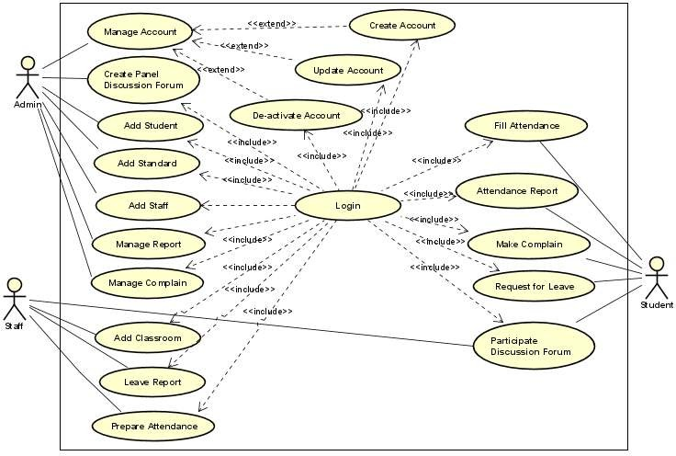
Figure 3-1 Use case Diagram

Use Case Description

Table 3-3 Login Use case Description
Use Case ID: 01
Use Case Name: Login
Actor: User (Admin, Student and Staff)
User: Wants to login to the system
Brief Description:
This use case describes how the user (Admin /Course and Lecturer) will login to the system in order to make use of order functions of the system
Input: Valid UserID and Password
Output: Has successfully Sign in
Pre-condition: User sign in using valid UserID and password
Post condition: The user can now make of the system function if is already registered user
Basic flow of Events:
- The system displays the homepage
- The user clicks on the login button
- The system displays the login page
- User key in username and password, and click login button
- The system verifies the provided details and, and then the system will display the particular user page
Exceptional Flows: E1 Key in wrong password and username
Alternate Flow: A1: Cancel
Constraints: Must key in a valid email address
Table 3-4 Manage User Usecase Description
Use Case ID: 03
Use Case Name: Manage User
Actor: Administrator
Administrator: Wants to add new user, delete user, edit user information
Brief Description:
This use case describes how the administrator login to the system to manage user
Input: Admin UserID and Password
Output: N/A
Pre-condition: Admin must log in to the system with valid UserID and Password
Post condition: The admin can now manage user
Basic flow of Events:
- The admin log into the system using its valid User ID and Password
- The system responds by verifying the Admin User ID and Password
- The admin page panel will now be displaying once the admin details has been verified by the system.
- The admin will then click on manage user button
- The system will then display the manage user page
- The administrator will then click on either edit user button, or delete user, or add new user button.
- The system will then display the particular page that the admin clicks on of
the functions
- The admin will then perform all the necessary process like add or edit user that he wants, and click the next button to finish.
- The system will then verify and save the new entries that been made by the
admin
- Thereafter, the system will now display new changes edited, added or deleted successfully
Exceptional Flows: E1 must have key in a wrong admin UserID and Password
Alternate Flow: A1: Cancel
Constraints: Must be an administrator
Table 3-5 Usecase Description for Add Standard
Use Case Name: Add Standard
Primary Actor: Admin
Stakeholders and Interest:
Administrator: Wants to set ground rule
Brief Description:
This use case describes how administrator to the student must attend the class and what will happen if they miss the class
Input: User Login information
Output: Standard Notified
Pre-condition: Must be a Valid one
Post condition: Admin now can Manage student and staff based on the standard
Basic flow of Events:
- The admin goes to the homepage
- The admin then clicks on login button
- The system then displays admin login page
- The admin key in their valid Username and Password
- The system the responds by verifying the Username & Password key into the system
- The system then displays the Add Standard panel homepage
- The admin then uploads the standard
- The admin click upload button
- The system displays conformation message
- The admin returns back to homepage
Exceptional Flows: E1 Invalid Username or Password, Standard not settled successfully
Alternate Flow: A1 User can cancel the upload process
Constraints: Password must be valid as well as Username
Table 3-6 Use case description for Prepare Attendance
Use Case Name: Prepare Attendance
Primary Actor: Staff
Lecturer: Wants to prepare attendance for the student
Brief Description:
This use case describes how the Lecturer prepare attendance in the system.
Input: Lecturer UserID and Password
Output: attendance was prepared successfully
Pre-condition: The Lecturer must log in to the system
Post condition: Lecturer can now prepare the attendance
Basic flow of Events:
- The Lecturer log into the system using its valid User ID and Password
- The system responds by verifying the Lecturer User ID and Password
- The Lecturer page panel will now be displaying once the admin details has been verified by the system.
- The Lecturer will now click on prepare attendance button
- The system will then display prepare attendance page
- The Lecturer will now enter the necessary student information and then click submit button.
- The system will then verify the prepare attendance and save the prepared attendance information
- The system will now display attendance prepared successfully.
Exceptional Flows: E1 Must prepare
Alternate Flow: N/A
Constraints: Must be Lecturer of MTU web-based attendance management system
Table 3-7 Use case description for Fill Attendance
Use Case Name: Fill attendance
Primary Actor: Student
Stakeholders and Interest: Student: Wants to sign attendance
Brief Description:
This use case describes how the student will check their result after giving their test.
Input: Student UserID and Password
Output: N/A
Pre-condition: The student must log on to the system
Post condition: The student can now generate attendance report
Basic flow of Events:
- The student log into the system using their valid User ID and Password
- The system responds by verifying the student User ID and Password
- The main page will now be displaying once the student details has been verified by the system.
- The student will then click on fill attendance button
- The system will then display the fill attendance page.
- The student will fill attendance
- The system finally, display conformation message
Exceptional Flows: E1 Wrong UserID and Password
Alternate Flow: N/A
Constraints: Must be a registered student.
Table 3-7 Usecase Description for Make Complain
Use Case Name: Make Complain
Primary Actor: Student
Stakeholders and Interest:
Student: Wants to make complain to admin and teacher
Brief Description:
This use case describes how the student will make any complain for concerning body.
Input: Student UserID and Password
Output: N/A
Pre-condition: The student must log on to the system
Post condition: The student can now generate the complaint submitted to admin/teacher
Basic flow of Events:
- The student log into the system using their valid User ID and Password
- The system responds by verifying the student User ID and Password
- The main page will now be displaying once the student details has been verified by the system.
- The student will then click on make complain button
- The system will then display the make complain page.
- The student will write any complain faced the student
- The system finally, display conformation message
Exceptional Flows: E1 Wrong UserID and Password
Alternate Flow: N/A
Constraints: Must be a registered student.

Sequence Diagram
The sequence diagram is used primarily to show the interactions between objects in the sequential order that those interactions occur. The main purpose of a sequence diagram is to define event sequences that result in some desired outcome. The focus is less on messages themselves and more on the order in which messages occur; nevertheless, most sequence diagrams will communicate what messages are sent between a system's objects as well as the order in which they occur. Sequence diagrams are used to model the logic of usage scenarios. Usage scenario is exactly which its name indicates-the description of a potential way our system is used. The logic of usage scenario developed here comprises the basic course of actions. The boxes across top of the diagram represent classifiers or their instances; typically use cases, objects, classes or actors.
The solid lines hanging from the boxes are called objects lifelines, representing the life span of object during the scenario being modeled. The long, thin boxes on the long-life lines are method invocation boxes indicating that the target object/class to fulfill a message is performing processing. Messages indicate as labeled arrows, when the source and the target of a message is an object or class label the signature of the method invoked in response to the message. However, if either the source or target is the human actor, then the message is labeled with brief text describing the information is available.

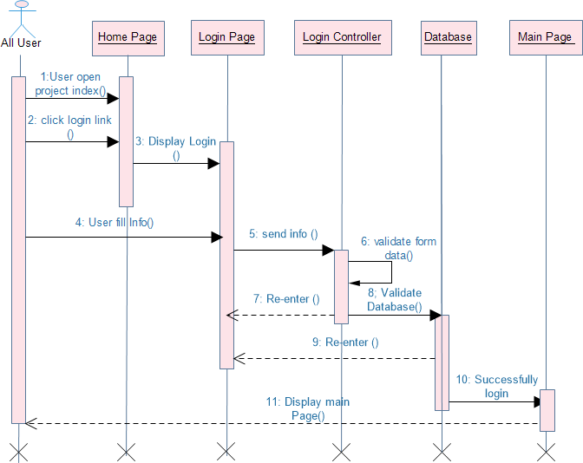

Figure 3-2 Sequence Diagram
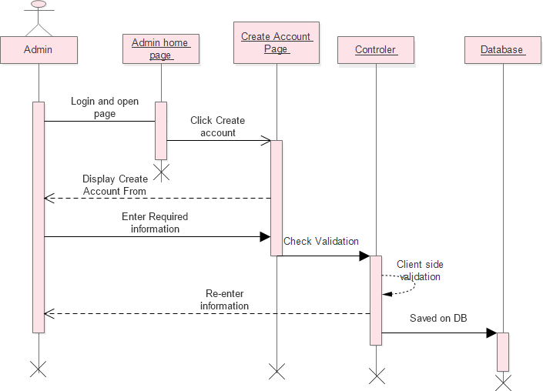

Figure 3-3 Sequence Diagram for Create Account

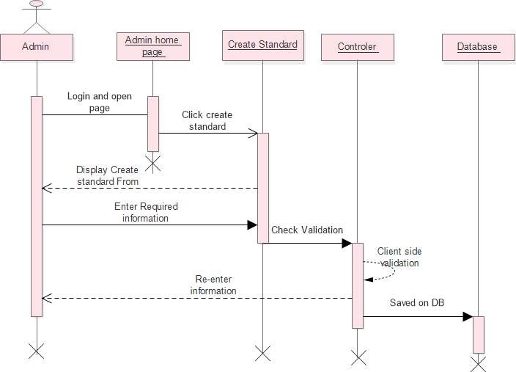
Figure 3-4 Sequence Diagram for create standard
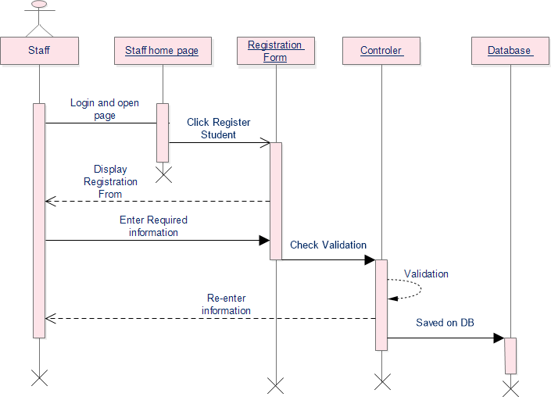
Figure 3-5 Sequence Diagram for Student Registration

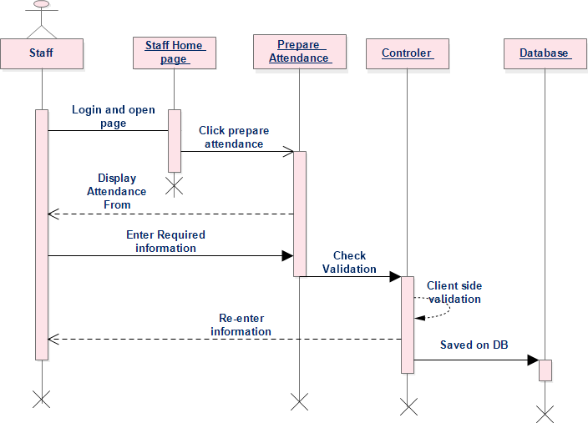
Figure 3-6 Sequence Diagram for Prepare Attendance

Activity Diagram
An activity diagram describes the behavior of a system in terms of activities. Activities are modeling elements that represent the execution of a set of operations. The execution of an activity can be triggered by the completion of other activities, by the availability of objects, or by external events. Activity diagrams are similar to flowchart diagrams in that they can be used to represent control flow (i.e., the order in which operations occur) and data flow (i.e., the objects that are exchanged among operations).
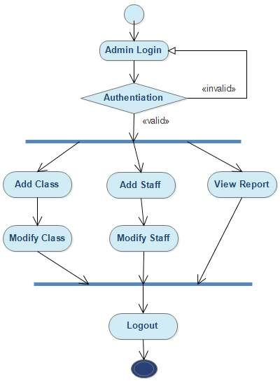
Figure 3-7 Admin side Activity Diagram for Student Attendance Management System

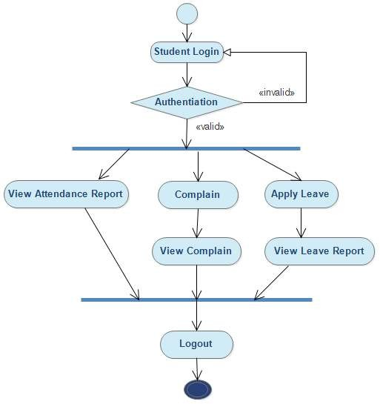
Figure 3-8 Student side Activity Diagram for Student Attendance Management System

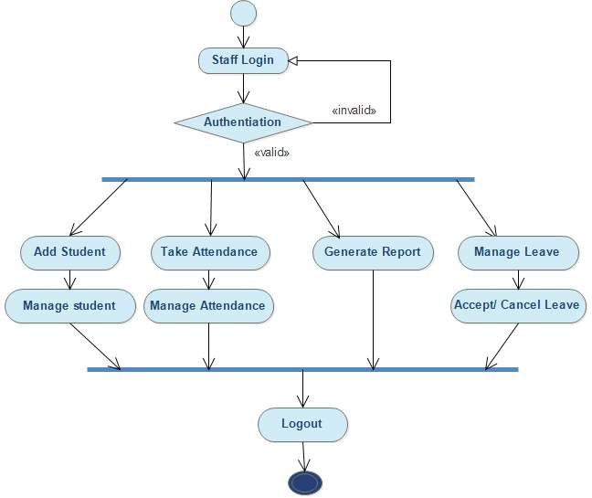
Figure 3-9 Staff side Activity Diagram for Student Attendance Management System

CHAPTER FOUR

SYSTEM DESIGN

Introduction
System modeling is the process and focuses on decomposing the system into manageable parts. During requirements elicitation and analysis, we concentrated on the purpose and the functionality of the system. During system design, we focus on the processes, data structures, and software and hardware components necessary to implement it. The challenge of system design is that many conflicting criteria and constraints need to be met when decomposing the system.
The analysis model describes the system completely from the actor’s point of view and serves as the basis of communication between the client and the developers. The analysis model, however, does not contain information about the internal structure of the system, its hardware configuration, or, more generally, how the system should be realized. System design is the first step in this direction. System design results in the following products:
- List of design goals, describing the qualities of the system that developers should optimize.
- Software architecture, describing the subsystem decomposition in terms of subsystem responsibilities, dependencies among subsystems, subsystem mapping to hardware, and major policy decisions such as control flow, access control, and data storage.
And the purposes of object –oriented paradigm document is to provide an overview as to how to actually be used the proposed system and to obtain the information needed to derive the actual implementation of our system.
This project is designed in a manner that solves the problems of the organization by minimizing the work load that appears on the employees because of the existing manual system. It provides more efficient, reliable and time saving system. In this project design the team will try to show:
  - How the project is designed
  - What are tasks done under the whole project
  - The different modules and their way of functioning are described here

Design Goal
The goal of system design according to the proposed project is to manage complexity by dividing the system into smaller, manageable pieces and to increase the system: -
- Efficiency: the system doing something well and thoroughly without waste of money and time.
- Flexibility: the system able to change to suite new condition or situation
- Security: the system should be secured, i.e., not allow unauthorized users to access the system.
- Reliability: the system should be reliable.
- Fault Tolerance: the system should be fault tolerant to loss of connectivity with the routing service
- Modifiability: the system should be modifiable to use different routing services.
There are a number of possible design criteria. These criteria are organized into four groups:

Performance criteria
Performance, dependability, and end user criteria are usually specified in the requirements or inferred from the application domain. The customer and the supplier (developer) dictate cost and maintenance criteria. It also includes: -
- Response time, the speed imposed on the system. The system should responsive maximum number of tasks with minimum times.
- Throughput, number of tasks accomplished in a fixed period of times.
- Memory, memory space available for speed optimizations should use efficiently.

Maintenance criteria
When we say the system is maintainable, we mean it can be maintained easily when changes arise from the user and designer/developers it is not only when changes arise but also when we consider the non-functional requirement.

Cost criteria
When we talk about cost, we mean the cost required for maintenance, installation and develop the system and to make the net worked computer to use the system effectively.

End user criteria
This is to mean the users of the system after the completion of the system, how the system is used in friendly manner for both the experienced and inexperienced users using the user interface and this is clearly stated in the users‟ documentation.

Class Diagram
Class diagrams are used to describe the structure of the system. Classes are abstractions that specify the common structure and behavior of a set of objects. Objects are instances of classes that are created, modified, and destroyed during the execution of the system. An object has state that includes the values of its attributes and its links with other objects. Class diagrams describe the system in terms of objects, classes, attributes, operations, and their associations.

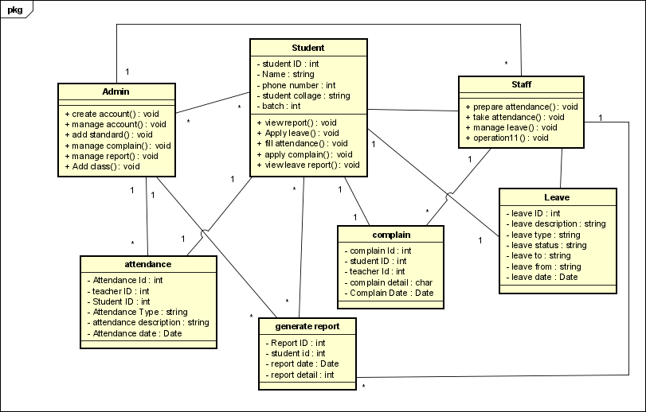
Figure 4-10 Class diagram

Component Diagram
A component diagram breaks down the actual system under development into various high levels of functionality. Each component is responsible for one clear aim within the entire system and only interacts with other essential elements on a need-to-know basis. Component Diagrams illustrate the pieces of software, embedded controllers, etc. that will make up a system. A Component diagram has a higher level of abstraction than a Class diagram usually a component is implemented by one or more classes (or objects) at runtime. They are building blocks, such that eventually a component can encompass a large portion of a system. So the basic components of online attendance management system are the following diagram:

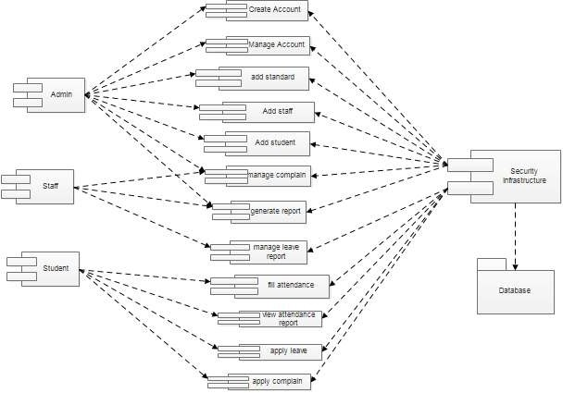

Figure 4-11 Component diagram

Deployment Diagram
A deployment diagram is a UML diagram type that shows the execution architecture of a system, including nodes such as hardware or software execution environments, and the middleware connecting them. Deployment diagrams are typically used to visualize the physical hardware and software of a system. Using it you can understand how the system will be physically deployed on the hardware. Deployment diagrams help model the hardware topology of a system compared to other UML diagram types which mostly outline the logical components of a system. Based on this the deployment diagram of student attendance management system is like the following:

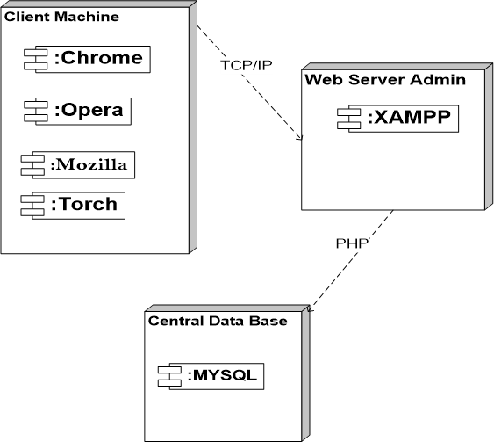

Figure 4-12 Deployment Diagram

References
- “(Approved by AICTE, Affiliated to Anna University and Accredited by NBA & NAAC with „A‟ Grade) MAY 2013,” vol. 003, no. May, 2013.
- S. Hassan, “Web-based Attendance Management System Submitted by Roll No : 08,” no. December 2015, 2018.
- P. Context, “Attendance management system project documentation”.
- “Attendance Management System”.

